**OUTPUT SCREENSHOT:**

**ARITHMETIC CALCULATOR:**

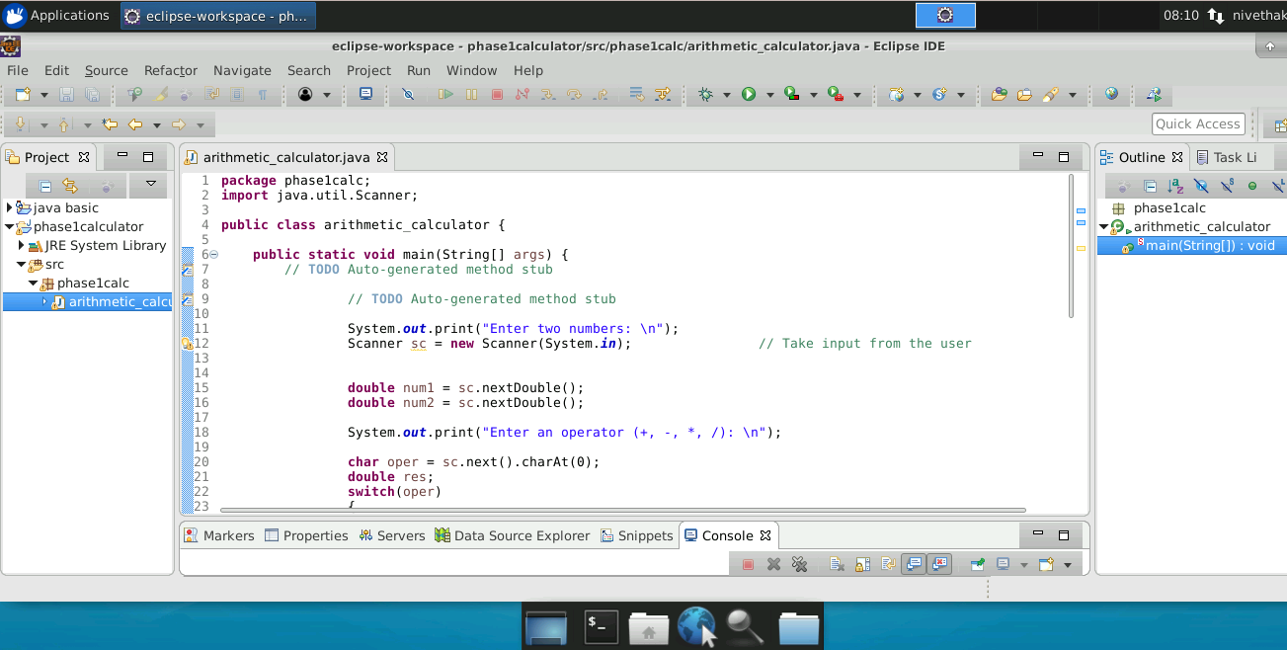

OUTPUT:

